Developer portal configuration you need to add to docker compose file:

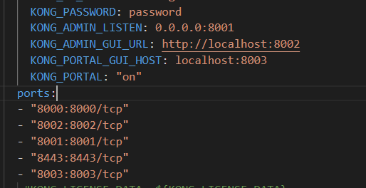

 KONG_PORTAL_GUI_HOST: localhost:8003

      KONG_PORTAL: "on"

Also you need to mention the port 8003 in port section.

Some of the below commands you need to run:

echo "KONG_PORTAL_GUI_HOST=localhost:8003 KONG_PORTAL=on kong reload exit" \ | docker exec -i kong-container-name /bin/sh

In place of kong-container-name add the docker container id of kong/kong-gateway.

You can get id using command docker ps.